
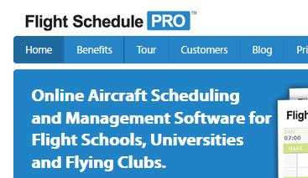
EVERETT  RENTON  www.befa.org
Starting April 1st!
Why are we doing this?
This web-base system will enhance BEFA resource utilization by allowing complete on-line management of:
- Significant Cost Savings
- Scheduling (planes, CFIs)

PAE ops will continue to lead BEFA’s transition by switching to exclusive on-line management of:
- Airplane dispatch
(check-out/in)
- Tach logs
- Maintenance tracking

How do I get started?
- Check it out at www.flightschedulepro.com
- Sign up for an account (see newsletter or www.befa.org)
- See the Users Guide inside the tach log or www.befa.org
- Keep using the paper tach log and squawk sheets in addition to Flight Schedule Pro as we make the transition
What if I have questions?
BEFA Office Staff
befa_office@mindspring.com
425-271-2332
Oliver Meier
oliver.meier@gmail.com
510-541-2142

Feb-2014
will replace Schedule Master
Flight Schedule Pro

