
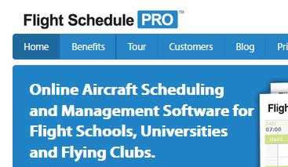
EVERETT  RENTON  www.befa.org
Attention BEFA Pilots
Starting Dec. 1st!
Why are we doing this?
This web-base system will enhance BEFA resource utilization by allowing complete on-line management of:
- Scheduling (planes, CFIs)
- Airplane dispatch
(check-out/in)
- Tach log
- Squawks
- Maintenance tracking
Is this for both Paine Field and Renton?
No. Paine Field is making the switch first as a pilot program. If it works well, it will be extended to Renton.
Assets at Renton (planes and CFIs) will still be through Schedule Master.
How do I get started?
- Check it out at www.flightschedulepro.com
- Sign up for an account (see newsletter or www.befa.org)
- See the Users Guide inside the tach log or www.befa.org
- Keep using the paper tach log and squawk sheets in addition to Flight Schedule Pro as we make the transition
What if I have questions?
Oliver Meier
oliver.meier@gmail.com
510-541-2142
Steve Kirsch
sakirsch@gmail.com
206-851-6663
Nov-2013
will replace Schedule Master at Paine Field
Flight Schedule Pro

